10/16/2024

Talha Rehman

FA22-BSE-159

Lab Task

SDA

**Use Case Diagram:**

**Fully Dress Use Case Diagram:**

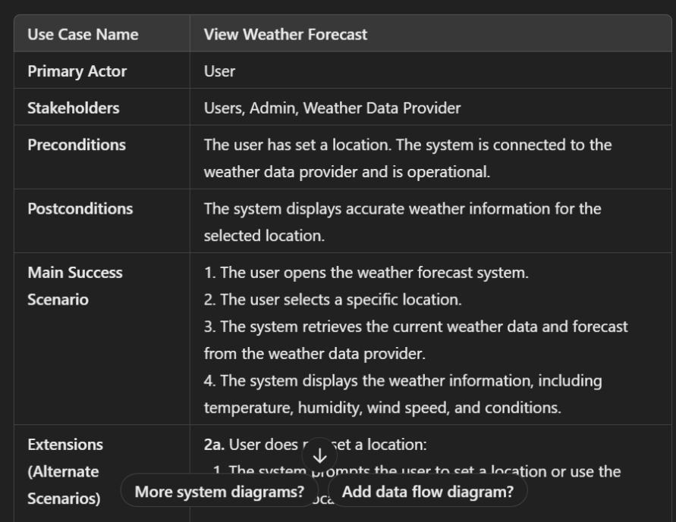

**Class Diagram:**

**System Sequence Diagram:**

**Communication Diagram:**

